Marine Resources Division Internship for Marine Biology / Environmental Studies
The Marine Resources Division is currently seeking interns interested in GIS, waterway management, fisheries, education/ outreach, and conservation. Do any of the below project examples interest you? Are you dependable, detail-oriented, and motivated? An internship with Marine Resources, Escambia County, would be an excellent addition to your resume. The application must be filled out completely and signed by hand. Applications not completed/ signed by hand or those that are not legible may not be reviewed.

Example projects: GIS mapping of beach morphology, various mapping of sea turtles and beach mouse items, assist with mapping for our artificial reefs. Assist in the monitoring of derelict vessels, assist in monitoring Harmful Algal Blooms (water quality). Potential to assist with artificial reef deployments and monitoring. Conduct coastal plant surveys and fisheries surveys. Assist in our education programs and materials for social media and events. And so much more! See the application packet for a full description.
Internship requires a commitment of one full semester (3 months) with a minimum of 8 hours per week.
These internships are a great way to find out what you want out of your career and gain invaluable work experience. Internships are generally voluntary and unpaid however occasionally grant funds become available for paid internships in different divisions. Directed study credit may also be possible, coordinate with your academic advisor.
To be accepted as an intern, candidates must do the following:
1. Submit the following:

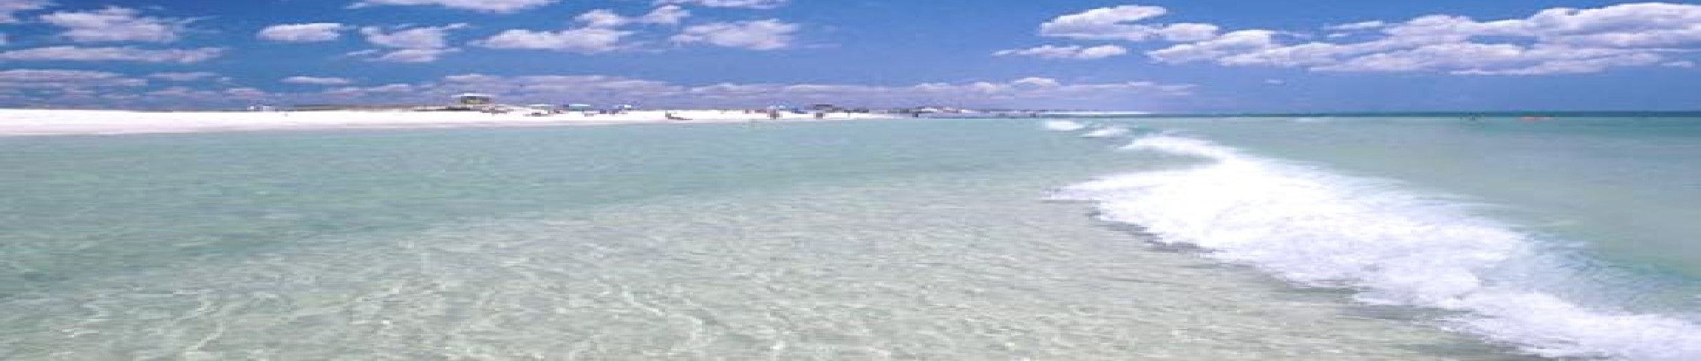

(i) volunteer candidate request form (application), (ii) a letter of interest (including which project topics you’re interested in), (Iii) Resume or current Curriculum Vitae, (iv) current full collegiate transcript (unofficial), (v) provide weekly availability

Escambia County, Marine Resources Division

Now Accepting Applications for 2026 Summer Internships

- Undergo a background check (using the completed application)
- Be interviewed by Division Manager/Staff
To apply, candidates should email their resume packets with the subject line “Candidate's last name: Summer 2026 Internship Application” to Blake Randall at berandall@myescambia.com. We are accepting applications now for a limited number of slots. Applications may be submitted as late as March 20, 2025.
