Escambia County Fire Rescue
2024 Annual Training Plan
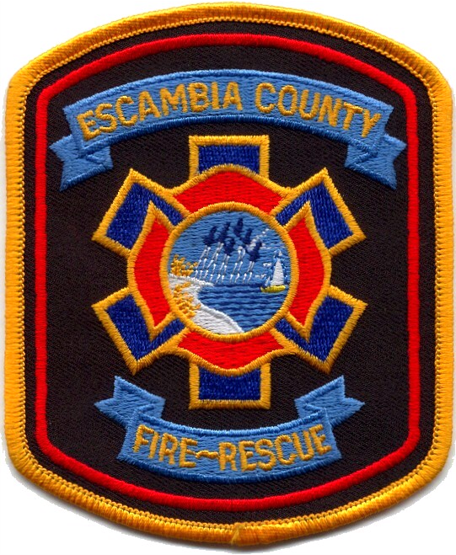
ECFR Training Division
Division Chief N. Robinson
6575 North “W” Street
Pensacola, FL 32505
850-471-6522
Mission Statement:

Escambia County Fire-Rescue is committed to providing effective and efficient fire-rescue services that meet the community’s needs in life protection, property conservation, preservation of the environment, and fire prevention programs.

“Do Basics Better”
Introduction:
ECFR is committed to providing a multitude of safe and efficient responses to the citizens and visitors of Escambia County. Within the 660+ square miles are numerous fire stations that provide the response needed to saving lives, protecting property, and ensuring hazard mitigation. ECFR provides the following types of responses:
- Fire Suppression: Structure, vehicle, wildland/urban interface
- Medical Response: BLS non-transport and ALS non-transport
- Hazardous Materials: Florida Regional Hazmat Response Team HM-1C and Operations Level Response
- Technical Rescue: Florida Regional Light Technical Rescue Team 104, Rope Rescue, Confined Space Rescue, Building Collapse Rescue, Trench Rescue, Vehicle and Machinery Rescue, and Swiftwater Rescue responses
- Water Rescue: Jet-ski and Open Water Rescue
With the variety of emergency responses, the training of the members of ECFR is critical to the safety in the mitigation of the calls. Volunteer members of ECFR are trained to the minimum Firefighter Part 1 and career firefighters as Florida Firefighter Part 2 certified. The training schedule is based on numerous requirements in the annual refresher completions per Insurance Services Office (ISO), NFPA, and the State of Florida. These requirements are broken up over the course of the year to consider variety of responses, member positions, specialty certifications, and departmental needs.
While the Training Division produces the 2024 Training Calendar, the Company Officer has the critical role of leading the company in the training. ECFR has recently added the position of Training Lieutenant and Volunteer Training Officer who report to the Training Division Chief. This coordination of effort allows a consistency of instruction and capability for those we serve.
Training topics will be color coordinated within the calendar, to assist with the planning and implementation of topic specific instruction. The online training platform, Target Solutions, will be used to provide instruction on specific topics also. This platform does not replace the need for Hands-On training but is to be a supplement for the hours and topics associated with the annual requirements.
Fire Suppression- RED
Hazardous Materials- GREEN
Medical Care- PINK
Driver/Operator- TURQUOISE
Water Rescue- GRAY
Officer Development- YELLOW
*- Target Solutions assignment

Within these blocks of training, the following total hours will be covered through hands-on, classroom, and online training.

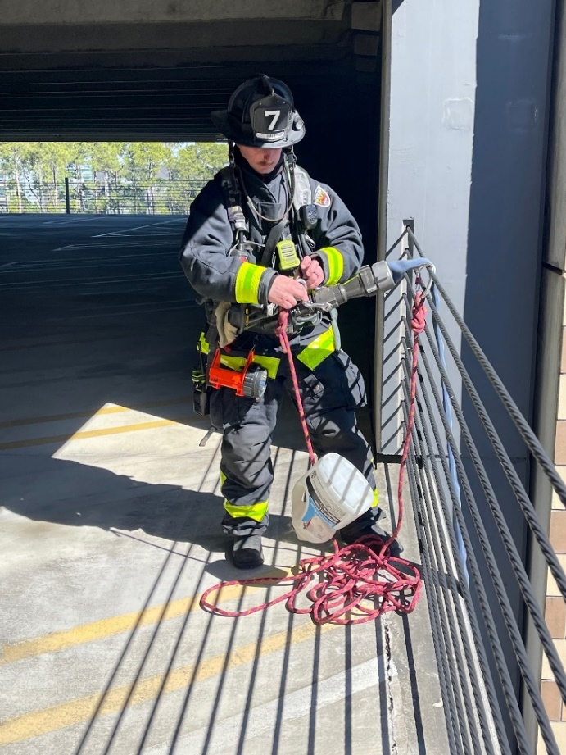
ISO, NFPA, NREMT, ECFR Requirements:
The Insurance Service Office establishes the fire protection rating for communities. The ISO rating dictates the level of protection available in the event of an emergency. Fire departments must meet minimum requirements to be given a specific rating. ECFR is currently an ISO Class rating of 4/4X. This includes the unincorporated areas of Escambia County. This rating does not pertain to the City of Pensacola or military bases located in Escambia County. NREMT EMR requirements are 8 per cycle (2 years). The EMS training will be quarterly during this time to ensure total compliance over the period, either in-person or online.

Company Training: 192 hours per year is required in accordance with the general criterial of NFPA 1001 Standard for Fire Fighter Professional Qualifications (average of 20 hours per month per firefighter)

Hazardous Materials Training: 6 hours per year is required. Training should be at a minimum awareness level in accordance with the general criteria of NFPA 472 Standard for Competence of Responders to Hazardous Materials / Weapons of Mass Destruction Incident. ECFR requires Operations Level response, due to Regional Hazmat Team needs. Hazmat 6 will provide training throughout the county quarterly to provide hands on exposure to the teams needs from operations staff.
Driver Training: 12 hours per year is required in accordance with the general criteria of NFPA 1002 Standard for Fire Apparatus Driver/Operator Professional Qualifications, and NFPA 1451 Standard for a Fire Service Vehicle Operations Training Program.

New Driver Training: One-time completion requirement of 60 hours. ECFR certification of SOG requirements. This includes initial SOG required hours.

Officer Training: The Officer Certification Requirement remains steady at 12 hours per year. Additional mandatory classes added for department-wide improvement.

Recruit Training: Personnel who automatically get credit if their department requires state certification as an employment pre-requisite, are required to complete 240 hours.
Beyond Minimum Standards Class meets 135 of these hours- 45 hours per week for 3 weeks.

Facility Training: This category, formerly “Training Drills,” refers to training done at a training facility. A training facility is defined as a 3-story tower on 2 acres of property with some sort of burn room, smoke room, or burn prop. Personnel are required to complete 18 hours per year.
With the continued movement of the Training Facility project, this will be a part of future training plans. Station 12 will have 2 training boxes for department training.

Pre-Planning Review: ECFR requires 5 commercial properties per month.

Urban Search and Rescue: 8 hours, per discipline, per year.

Water Rescue: USLA requirements of 16 hours annually

Medical: NREMT EMR requirements of 16 hours annually

As the fire department has become the “Swiss Army Knife” of response agencies, the training associated with the requirements of the calls for service must be ongoing. Training is the basis of the knowledge and capability of the department and a reflection into the priorities of that department. ECFR Company Officers will provide the company level training at the direction of the Training Division. While each company and officer are unique, the basis of service and ability must remain at a high level. Officers should consider the member’s time in rank, exposure to incidents within their response area, and the statistics of high risk/low probability calls. The Officer is encouraged to reach out to surrounding districts to coordinate, through their chain of command, the multi-company training as to provide a common capability of the department. When providing the training, remember that basics always work. The complication of steps will guarantee more possibility of failure. Knowing the basics also allows for the escalation of the incident to dictate the tactics to be used, based on the level of training available. The Training Division has the onus to provide the platforms for the other forms of training and requirements into the annual plan.

The Training Lieutenants and Volunteer Training Officer will coordinate the plan with the Battalion and Districts Chiefs to facilitate the delivery of a standardized message and content. Training outside of the scheduled plan is encouraged, specific to opportunities available, structures for demolition, or situations of specialized event planning. While these are to be considered extracurricular, the training plan can be altered in specific, department-wide beneficial opportunities. The Company Officer facilitating the extra training is requested to coordinate through their respective Training Division representative.
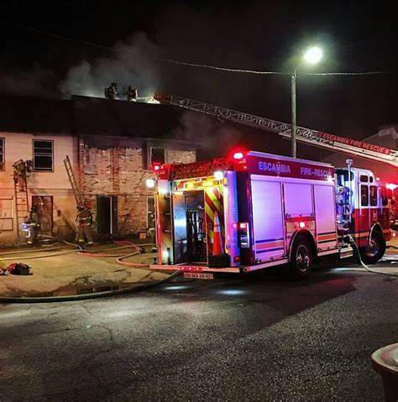

January 2024
Date | Class Name | Training Category | Training Topic | Objective | SOG
12/31-1/6 | Flat Loads | Company | Hose | Hose: Stretching Horizontal
 | On-Scene Staging | Driver | Company Operations | Drivers Training: Staging | 3105.015
1/7-1/13 | Water Supply- Hydrants | Company | Water Supply | Company Operations: Water Supply
 | First Responder Operations Level Refresher MOD #1* | Hazmat | Hazmat General | Hazmat: Annual Refresher
1/14-1/20 | SCBA Confidence | Company | Health and Safety | Health and Safety: SCBA Proficiency
 | EMS Respiratory Emergencies Basic* | Medical | Medical | Medical: Respiratory | Protocol 2.2 Adult Respiratory Emergencies
1/21-1/27 | Introduction to Wildland Fire Behavior* | Company | Fire Behavior | Fire Behavior: Wildland Fire
Training Division Offerings: A Watch Station Inspections Due
BFST 2720 Company Officer
January 13, 14, 20, 21
Station 12 Classroom
February 2024
Date | Class Name | Training Category | Training Topic | Objective | SOG
2/4-2/10 | Gustin Packs | Company | Hose | Hose: Stretching Horizontal
 | Daily Inspections and Maintenance | Driver | Drivers Training: Maintenance | Company Operations: Water Supply | 1215.015
2/11-2/17 | Lifting and Moving | Company | Extrication | Extrication: Vehicle Stabilization
2/18-2/24 | Firefighter CPR | Company | Health and Safety | Search: Rapid Intervention Team
2/25-3/2 | Building Construction* | Company | Building Construction | Building Systems: Building Construction
Mandatory Quarterly Officer Development Training:
February 13 or 15th, 0900-1200
Fire Headquarters
Training Division Offerings:
BFST2741- Fire Service Course Design
February 12-16
Station 6

REVIEW/UPDATE MEMBER/EMPLOYEE INFO IN DEPARTMENT REPORTING SOFTWARE

March 2024
Date | Class Name | Training Category | Training Topic | Objective | SOG
3/3-3/9 | Vertical Stretching | Company | Company Operations | Hose: Stretching Vertical
 | Multiple Line Flowing | Driver | Drivers Training: Multiple Lines | Vehicle Operations: Apparatus Pump Training
3/10-3/16 | Ground Ladders | Company | Portable Ladders | Portable Ladders: Carries, Raises, and Placement
3/17-3/23 | Fires in Sprinklered Buildings | Company | Building Systems | Building Systems: Standpipe/Sprinklers | 4100.012
3/24-3/30 | Vehicle Extrication: Size Up | Company | Extrication | Extrication: Size-up
Training Division Offerings:
BFST1810- Tactics and Strategies 1 RN 3268 FLUSAR Rope Rescue Operations
March 18-22 March 9, 10, 23, 24
Station 12 Station 9

*-Hose Testing Month
April 2024
Date | Class Name | Training Category | Training Topic | Objective | SOG
3/31-4/6 | Forcible Entry: Residential G-S-F | Company | Forcible Entry | Forcible Entry: Conventional | 4100.040
 | Winching Operations* | Driver | Vehicle Operations | Vehicle Operations: Winching
4/7-4/13 | Firefighter Through the Floor | Company | Health and Safety | Health and Safety: Firefighter Safety & Survival
 | EMS Managing Cardiac Arrest: During and After Resuscitation* | Medical | Medical | Medical: Cardiology | Protocol 2.3.8 (ROSC)
4/14-4/20 | Hand Tool Selection | Company | Tools and Equipment | Tools and Equipment: Hand Tools
 | Throw Rope Operation* | Water Rescue | Water Rescue | Water Rescue: Shore Operations
4/21-4/27 | Extreme Weather/Hurricanes | Company | Extreme Weather/Hurricane | Administrative Functions: SOG Review | 8100.015  8100.005
Training Division Offerings: B Watch Safety Inspections Due/* Hydrant Testing Month
BFST1301- Fire Service Hydraulics RN 3265- FLUSAR Confined Space Ops
April 22-26 April 6, 7, 13, 14
Station 6 Station 9

May 2024
Date | Class Name | Training Category | Training Topic | Objective | SOG
4/28-5/4 | Vent-Enter-Search | Company | Search | Search: Vent Enter Search
 | Hydra-Assist Valve | Driver | Water Supply | Company Operations: Water Supply
5/3-5/11 | Residential Roof Construction | Company | Building Construction | Building Systems: Building Construction
 | First Responder Operations Level Refresher MOD #2* | Hazmat | Hazmat | Hazmat: Annual Refresher
5/12-5/18 | Helicopter Operations | Company | Operational Safety Classes | Operational Safety: Medical Aircraft Safety Training | 4100.045
5/19-5/25 | Gas Powered Saws:  Operation and Care | Company | Tools and Equipment | Tools and Equipment: Gas Powered | 1225.010
Mandatory Quarterly Officer Development Training: *- Hydrant Testing Month
May 7 or 9, 0900-1200
Fire Headquarters
Training Division Offerings:
BFST1302- Fire Apparatus Operations RN 3267 FLUSAR VMR Ops
May 13-17 May 4, 5, 11, 12
Station 6 Station 9
June 2024
Date | Class Name | Training Category | Training Topic | Objective | SOG
6/2-6/8 | Extended Stretches | Company | Hose | Hose: Stretching Horizontal
 | Booster Back Up | Driver | Water Supply | Company Operations: Water Supply
6/9-6/15 | Search and Rescue | Company | Search | Search: Basic Interior Search Patterns
 | EMS Managing Cardiac Arrest: During and After Resuscitation* | Medical | Medical | Medical: Cardiology | Protocol 2.3.8 Return of Spontaneous Circulation (ROSC)
6/16-6/22 | Salvage and Overhaul | Company | Salvage and Overhaul | Company Operations: Truck Company
6/23-6/29 | Elevator Emergencies | Company | Extrication | Extrication: Elevator Rescues | 4100.050
Training Division Offerings:
BFST 6742 Incident Safety Officer
June 24-28
Station 6

July 2024
Date | Class Name | Training Category | Training Topic | Objective | SOG
6/30-7/6 | Garage Fires | Company | Hose | Hose: Stretching Horizontal
 | Split Lay/Beyond the Preconnect | Driver | Vehicle Operations | Vehicle Operations: Apparatus Pump Training
7/7-7/13 | Forcible Entry: Commercial | Company | Forcible Entry | Forcible Entry: Conventional | 4100.040
 | EMS GERIATRIC EMERGENCIES BASIC* | Medical | Medical | EMS: General
7/14-7/20 | Cancer Awareness and Prevention | Company | Health and Safety | Health and Safety: Firefighter Health and Safety | 1225.005  3500.025  1225.035
7/21-7/27 | Calling the Mayday | Company | Health and Safety | Health and Safety: Firefighter Safety and Survival
Training Division Offerings: *C Watch Safety Inspections Due
BFST1540- Private Fire Protection Systems 1
July 23-26
Station 12

August 2024
Date | Class Name | Training Category | Training Topic | Objective | SOG
8/4-8/10 | Electric Vehicle Fires | Company | Fire Behavior | Fire Behavior: Electric/Hybrid Vehicles | 4100.020
 | Multiple Line Flowing | Driver | Drivers Training | Drivers Training: Multiple Lines
8/11-8/17 | Commercial Roof Construction | Company | Building Systems | Building Systems: Building Construction
8/18-8/24 | ASHER Incidents | Company | Health and Safety | Health and Safety: ASHER Response | 4100.085
 | First Responder Operations Level Refresher MOD #3* | Hazmat | Hazmat | Hazmat: Annual Refresher
8/25-8/31 | Thermal Imagers | Company | Fire Behavior | Fire Behavior: Thermal Imager
Mandatory Quarterly Officer Development Training:
August 27 or 29, 0900-1200
Fire Headquarters
Training Division Offerings:
BFST3530- Live Fire Training Instructor FLUSAR Rope Rescue Ops
August 19-23
Station 12

September 2024
Date | Class Name | Training Category | Training Topic | Objective | SOG
9/1-9/7 | Class B Fires | Company | Fire Behavior | Fire Behavior: Class B Fires
 | Foam Operations | Driver | Driver Training | Drivers Training: Foam Operations
9/8-9/14 | Blitz Attacks | Company | Hose | Hose: Stretching Horizontal
 | EMS PEDIATRIC EMERGENCIES BASIC* | Medical | Medical | Medical: General Pediatric
9/15-9/21 | Through the Lock | Company | Forcible Entry | Forcible Entry: Through the Lock | 4100.040
9/29-10/5 | Lost Persons | Company | Rescue | Search: Lost Person | 4100.105
Training Division Offerings:
BFST1740- Fire Service Course Delivery FLUSAR Con-Space Ops
September 9-13
Station 6

October 2024
Date | Class Name | Training Category | Training Topic | Objective | SOG
10/6-10/12 | High Rise Fires | Company | Company Operations | Company Operations: High-rise
 | Large Volume Flowing:  RAM and Deck Gun | Driver | Drivers Training | Drivers Training: Master Streams
10/13-10/19 | Nuisance Fires:  Trash/Dumpster | Company | Company Operations | Company Operations: Engine Company | 4100.030  4100.035
10/20-10/26 | Firefighter Mental Health | Company | Health and Safety | Health and Safety: Firefighter Health and Safety
 | EMS STROKE ASSESSMENT AND TREATMENT* | Medical | Medical | Medical: General Adult | 2.5.5 Suspected CVA
10/27-11/2 | Modern Vehicle Extrication | Company | Extrication | Extrication: Size-up
Training Division Offerings: *C Watch Station Inspections Due
BFST1301- Fire Service Hydraulics FLUSAR VMR Ops
October 14-18
Station 12

November 2024
Date | Class Name | Training Category | Training Topic | Objective | SOG
11/3-11/9 | Rapid Intervention Teams | Company | Search | Search; Rapid Intervention Team
 | EVOC Driving Course | Drivers | Drivers Training | Vehicle Operations: Drivers Training
11/10-11/16 | Vertical Ventilation | Company | Fire Behavior | Fire Behavior: Vertical Ventilation
 | First Responder Operations Level Refresher MOD #4* | Hazmat | Hazmat | Hazmat: Annual Refresher
11/17-11/23 | Kitchen Fires | Company | Fire Behavior | Fire Behavior: Kitchen Fires
11/24-11/30 | Rope Assisted Search | Company | Search | Search: Rope Assisted
Mandatory Quarterly Officer Development Training: Training Division Offerings:
November 12 or 14, 0900-1200 BFST1302- Fire Apparatus Operations
Fire Headquarters November 4-8
Station 6
FLUSAR Trench Ops

December 2024
Date | Class Name | Training Category | Training Topic | Objective | SOG
12/1-12/7 | Attic Fires | Company | Fire Behavior | Fire Behavior: Attic Fires
 | Scene Safety at Roadway Incidents | Driver | Health and Safety | Health and Safety: Scene Safety | 3500.020
12/8-12/14 | Commercial Vehicle Extrication | Company | Rescue | Extrication: Commercial Vehicles
 | EMS ASSESSING THE PATIENT WITH MAJOR TRAUMA* | Medical | Medical | Medical: Trauma Adult | 2.10. 1-11 Adult Trauma Protocols
12/15-12/21 | Firefighter Survival: Bumps to Pumps | Company | Health and Safety | Health and Safety: Firefighter Safety & Survival
12/22-12/28 | Firefighter Survival: Air Management | Company | Health and Safety | Health and Safety: Firefighter Safety and Survival
Training Division Offerings:
BFST2120- Building Construction FLUSAR Collapse Ops
December 2-6
Station 12

With the completion of the above annual training, Companies will complete all the expected requirements. The documentation of the training is as important as the task. If an assignment is given in Target Solutions for completion, there is no need for duplication in 1st Due. The reports will be set to monitor completion and officers can request, via Training Lieutenants, their company’s status.
While setting a time expectation for each training session, the total hours throughout the year for all training is 192 hours. This will include company, medical, hazmat, and drivers training. Though 192 is the minimum, there is no maximum. The training plan should be used as a guide and can be supplemented by the company officer or Battalion Chief as needed. There may also be acquired structures, which are often unpredictable, that can alter or add to the training plan. The best training is always hands on, and acquired structures will assist in the most realistic, situational training available.
The monthly Training Division offered classes are also flexible, based on instructor availability. These classes cover the required courses for Fire officer 1, Fire Officer 2, Instructor 1, Instructor 2, and some other higher-level certifications also. These are available to local departments at no cost, with the agreement with the access to their classes also. As those come into the division, advertisement will be sent as soon as possible for your planning and registration.
As the weekly training develops, the Training Division will begin to write procedures for the standardization of these tasks. Input from members in Operations is coveted for experienced based practices that have been successful on scene and trainings. As the department grows, the standardization of tasks is needed to set the minimum expectations of firefighter capability. The standard is then a baseline for the development of the company by the officer. The Training Division is responsible for facilitating and providing the objectives for the tasks given.

