Escambia County Fire Rescue

2025 Annual Training Plan

ECFR Training Division

Division Chief N. Robinson

6575 North “W” Street

Pensacola, FL 32505

850-471-6522

**Mission Statement:**

Escambia County Fire-Rescue is committed to providing effective and efficient fire-rescue services that meet the community’s needs in life protection, property conservation, preservation of the environment, and fire prevention programs.

“Basics Always Win”

**Introduction:**

As the department grows, the need for ongoing training at all levels expands. The vastness of the calls we respond to as an agency allows for the experience to grow quickly also. We are the largest fire department is the Panhandle, and as such, have an unwritten responsibility to lead by example. The example is in our mission statement, with emphasis on “*life protection, property conservation, preservation of the environment, and fire prevention programs.*”

The main topics in the calendar that meet ISO, NFPA, NREMT, and FSFC requirements are:

**Fire Suppression:** *private dwelling, multiple dwellings, mid/high rises, vehicles (private and commercial), and wildland/urban interface*

**Medical Responses:** *BLS non-transport, ALS non-transport*

**Hazardous Materials:** *Chemical, Biological, Radiological, Nuclear, and Explosive response and detection with Florida HM-1C.*

**Technical Rescue:** *Rope Rescue, Confined Space, Building Collapse, Trench/Excavation Rescue, Vehicle and Machinery Rescue, and Swiftwater Rescue conducted with FLUSAR LTRT 104.*

**Water Rescue:** *Open Water and Surf Rescue*

With each specialty comes ongoing and updated training to meet both national and state requirements as set by the AHJ of the Chief of the Department. With that challenge comes the onus of the Training Division to maintain and exceed all required training for all department members. Training is coordinated through the Training Captains and Shift Lieutenants with direction and control from the Department’s Division Chief of Training.

**Process:**

Each year, in accordance with ECFR SOG 1220.005, the Training Division sets a general calendar to provide direction to meet the above standards. The documentation of the training is vital to the goals of the division and the requirements of the above agencies. On the calendar below, a color scheme will be used to help guide the company officers and District Chiefs with how to document for consistency.

Fire Suppression- RED

Hazardous Materials- GREEN

USAR- TEAL

Medical Care- PINK

Driver/Operator- BLUE

Water Rescue- GRAY

Officer Development- YELLOW

The *preferred* method of training remains hands on at the company and multi-company levels. There is only **ONE** Online Training Module assigned per month to maintain requirements. Below are the explanations and goals for the total hours for each member and company within ECFR:

**ISO, NFPA, NREMT, ECFR Requirements:**

The Insurance Service Office establishes the fire protection rating for communities. The ISO rating dictates the level of protection available in the event of an emergency. Fire departments must meet minimum requirements to be given a specific rating. ECFR is currently an ISO Class rating of 4/4X. This includes the unincorporated areas of Escambia County. This rating does not pertain to the City of Pensacola or military bases located in Escambia County. NREMT EMR requirements are 8 per cycle (2 years). The EMS training will be quarterly during this time to ensure total compliance over the period, either in-person or online.

*Company Training*: 192 hours per year is required in accordance with the general criterial of NFPA 1001 Standard for Fire Fighter Professional Qualifications (average of 20 hours per month per firefighter)

*Hazardous Materials Training*: 6 hours per year is required. Training should be at a minimum awareness level in accordance with the general criteria of NFPA 472 Standard for Competence of Responders to Hazardous Materials / Weapons of Mass Destruction Incident. ECFR requires Operations Level response, due to Regional Hazmat Team needs.

**2025 Goals:** *Hazmat 6 will provide training throughout the county quarterly to provide hands on exposure to the teams’ needs from operations staff. This will apply to Technicians and all Operations level members.*

*Driver Training*: 12 hours per year is required in accordance with the general criteria of NFPA 1002 Standard for Fire Apparatus Driver/Operator Professional Qualifications, and NFPA 1451 Standard for a Fire Service Vehicle Operations Training Program.

**2025 Goal:** *Completion of EVOC driving course for all certified drivers, implementation of a formal Aerial Driver Operator certification, specific drivers training in trailers, ATV/UTV, and all utility vehicles. EVOC instructors will coordinate with BC’s and DC’s for scheduling training.*

*New Driver Training*: One-time completion requirement of 60 hours. ECFR certification of SOG requirements. This includes initial SOG required hours.

**2025 Goals:***Provide 2 EVOC classes annually, provide required in-person classes Annually (Hydraulics and Apparatus Operations)*

*Officer Training*: The Officer Certification Requirement remains steady at 12 hours per year. Additional mandatory classes added for department-wide improvement.

**2025 Goals:** *Internal and External presentations from Leadership provided quarterly for all Officers, career and volunteer.*

*Recruit Training*: Personnel who automatically get credit if their department requires state certification as an employment pre-requisite, are required to complete 240 hours.

**2025 Goals:** *Increase BMSC to provide maximum preemployment training meeting the variety of needs for the new firefighter*

*Facility Training*: This category, formerly “Training Drills,” refers to training done at a training facility. A training facility is defined as a 3-story tower on 2 acres of property with some sort of burn room, smoke room, or burn prop. Personnel are required to complete 18 hours per year. With the continued movement of the Training Facility project, this will be a part of future training plans. Station 12 will have 2 training boxes for department training, with development of Station 18 for north end units.

*Pre-Planning Review*: ECFR requires 5 commercial properties per month.

**2025 Goals:** *Continue the required 5 pre-plans and have each company identify their own personal goals for their shift and station. Create training opportunities based around building/facility familiarization*

*Urban Search and Rescue*: 8 hours, per discipline, per year.

**2025 Goals:** *Continue Operations level training for those selected in the USAR Pipeline. Complete training for Technician Level courses and instructor check offs. Coordinate with Team Leader for maximum hands-on capabilities for the team and all ECFR members.*

*Water Rescue*: USLA requirements of 16 hours annually

**2025 Goals:** *Coordinate JPR based training for skill specific tasks. All Water Rescue members to complete the training annually for certification/renewal. Coordinate with Team Leader for rotation of members and tasks to ensure maximum skills in open water and surf rescues*

*Medical:* NREMT EMR requirements of 16 hours annually

**2025 Goals:** *EMR/EMT/Paramedic**skills introduced and tested during annual recertification process. Maintain CEU opportunities for all members to maximize education and capabilities. Ensure proper documentation of medical contacts.*

**January 2025**

|  |  |  |  |  |
| --- | --- | --- | --- | --- |
| **Date** | **Class Name** | **Training Category** | **Training Topic** | **Objective** |
| 12/29-1/4 | Extended Stretch from Rear Hose Bed | Company | Hose | Hose: Stretching Horizontal |
| 1/5-1/11 | Water Supply:  Flow rates, sources, and options for accessing | Company | Water Supply | Company Operations: Water Supply |
| 1/12-1/18 | Ground Ladders:  VES Throw, assignments, and entry/exit | Company | Portable Ladders | Portable Ladders: Carries, raises, and placement |
| 1/19-1/25 | Hand Tool: Forcible Entry  Irons, Hook, Hydra-Ram, etc. | Company | Tools and Equipment | Tools and Equipment: Hand Tools |
| 1/26-2/1 | Officer Selection: Company Specific Needs | Company | *as appropriate | *as appropriate |

Online Training: Target Solutions, First Responder Hybrid Vehicle Incidents (134860)

Officer: Fire Station Safety Inspection (A Watch)

**February 2025**

|  |  |  |  |  |
| --- | --- | --- | --- | --- |
| **Date** | **Class Name** | **Training Category** | **Training Topic** | **Objective** |
| 2/2-2/8 | Firefighter Survival/SCBA Confidence | Company | Health and Safety | SCBA Proficiency |
| 2/9-2/15 | Firefighter MAYDAYs and Radios | Company | Health and Safety | Mobile/Portable Radio |
| 2/16-2/23 | Thermal Imaging | Company | Fire Behavior | Thermal Imager |
| 2/23-3/1 | Firefighter CPR | Company | Health and Safety | Firefighter CPR |

Online Training: RT-130 Annual Wildland Fire Safety Refresher- Module 1 (140837)

EMS: **\*EMS In-Service Training February 11 or 13**

USAR: JPR Skill- Rope System- Converting 3:1 to Higher Systems

Officer: 6000.030 PPE Care (Inspect Primary and Backup Gear)

**\*Quarterly Officer Training February 18 or 20**

Water Rescue: JPR Skill- Reach and Throw

Driver: SOG 3000.015 Staging

**\*PEER Fitness Assessments Begin**

**HOT Training Station 12- Maze and MAYDAY**

**March 2025**

|  |  |  |  |  |
| --- | --- | --- | --- | --- |
| **Date** | **Class Name** | **Training Category** | **Training Topic** | **Objective** |
| 3/2-3/8 | Defensive Retreats | Company | Hose | Fire Streams |
| 3/9-3/15 | Building Construction | Company | Building Systems | Building Construction |
| 3/16-3/22 | Vehicle Extrication Size-up | Company | Extrication | Size-up |
| 3/23-3/29 | Emergency Response Guidebook: Book and Digital | Hazmat | Hazmat Awareness | Emergency Response Guide |

Hazmat: JPR Skill- Sampling Solids, Liquids and Gases

Officer: SOG 4100.060 False Fire Alarm Reporting

Water Rescue: JPR Skill- Maintenance of Equipment

* 8, 13, 19- Ski, Trailer, Truck
* 3, 4, 16- RIB, Flats boat, Trailer, Truck

Driver: SOG 4000.055 Aggressive Driving

**April 2025**

|  |  |  |  |  |
| --- | --- | --- | --- | --- |
| **Date** | **Class Name** | **Training Category** | **Training Topic** | **Objective** |
| 3/30-4/5 | Standpipe Operations | Company | Building Systems | Standpipe/Sprinklers |
| 4/6-4/12 | Salvage and Overhaul | Company | Salvage and Overhaul | Tarps and Covers |
| 4/13-4/19 | Sprinklered Building Responses | Company | Building Systems | Standpipe/Sprinklers |
| 4/20-4/26 | Extreme Weather/Hurricanes | Company | Extreme Weather/Hurricanes | Administrative Functions: SOG Review |
| 4/27-5/3 | Officer Selection:  Company Specific Need | Company | *as appropriate | *as appropriate |

Online Training: Target Solutions- NFPA 1021 Pre-Incident Planning (9535)

EMS: \***EMS In-Service Training April 8 or 10**

USAR: JPR- Anchor Selection VMR, Rope, and Collapse Applications

Officer: SOG 6000.060 Station Logbook

*Fire Station Safety Inspection (B Watch)

Water Rescue: SOG 3000.070

Driver: EVOC Driving Course- Primary Apparatus

HOT: Driving Range at Fleet

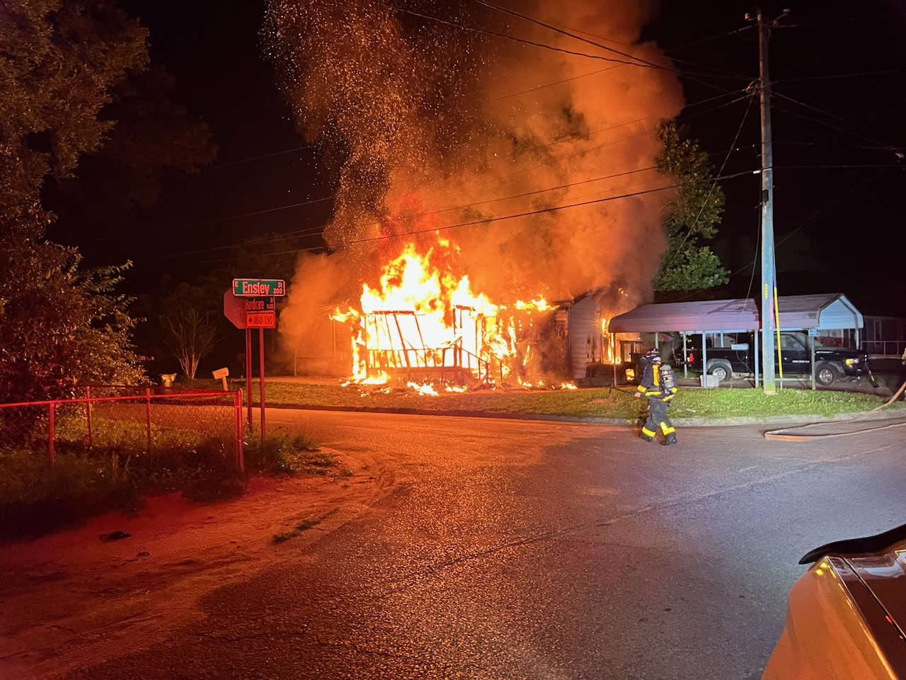

**May 2025**

|  |  |  |  |  |
| --- | --- | --- | --- | --- |
| **Date** | **Class Name** | **Training Category** | **Training Topic** | **Objective** |
| 5/4-5/10 | Vertical Stretching | Company | Hose | Hose: Stretching Vertical |
| 5/11-5/17 | Saws: Battery Operated | Rescue | Extrication | Battery Operated Saws |
| 5/18-5/24 | Vehicle Stabilization | Rescue | Extrication | Vehicle Stabilization |
| 5/25-5/31 | Water Rescue Awareness | Company | USAR | Surface/Flood Water |

Online Training: RT-130: Annual Wildland Fire Safety Refresher Training (186221)

USAR: JPR Skill- Air Monitoring in Confined Space and Collapse Application

Hazmat: JPR Skill- Air Monitoring in Confined Space and Collapse Application

Officer: SOG 3000.120 Incident Rehab

Quarterly Officer Training May 6 or 8

Water Rescue: JPR Skill: Rescuing an Unconscious Victim

Driver: SOG 4000.005 Response Mode

**June 2025**

|  |  |  |  |  |
| --- | --- | --- | --- | --- |
| **Date** | **Class Name** | **Training Category** | **Training Topic** | **Objective** |
| 6/1-6/7 | Battery Fires | Company | Fire Behavior | Battery Fires |
| 6/8-6/14 | Mental Health | Company | Health and Safety | Firefighter Mental Health |
| 6/15-6/21 | Firefighter Rehab | Company | Health and Safety | Firefighter Rehab |
| 6/22-6/28 | Electrical Safety | Company | Health and Safety | Electrical Safety |

EMS: Target Solutions: EMS Heat Illness and Emergency

**\*EMS In-Service Training June 24 or 26**

Officer: SOG 7000.005 PPE Decon/Cancer Prevention

Water Rescue: JPR Skill- Rescue Board/Can

Driver: SOG 4000.080 Apparatus out of Service

HOT: EVOC-Trailer Driving

HOT: Safety Stand Down

**July 2025**

|  |  |  |  |  |
| --- | --- | --- | --- | --- |
| **Date** | **Class Name** | **Training Category** | **Training Topic** | **Objective** |
| 6/29-7/5 | Inward/Outward Swinging Forcible Entry | Company | Forcible Entry | Conventional |
| 7/6-7/12 | Less than Lethal/  Through the Lock | Company | Forcible Entry | Through the Lock |
| 7/13-7/19 | Nuisance Fires: Trash/Dumpster | Company | Fire Behavior | Trash/Nuisance Fires |
| 7/20-7/26 | Electric Vehicle Fires | Company | Fire Behavior | Electric/Hybrid Vehicles |
| 7/27-8/2 | Officer Selection:  Company Specific Need | Company | *as appropriate | *as appropriate |

USAR: JPR Skill- Lifting and Moving/Estimating weights and Appropriate Equipment

Officer: SOG 3000.100 ASHER Incidents

*Fire Station Safety Inspection (C Watch)

Water Rescue: JPR Skill- Rescuing Conscious Victim

Driver: SOG 4000.025 Speed Limitations

HOT: Forcible Entry Props at 6/12

**August 2025**

|  |  |  |  |  |
| --- | --- | --- | --- | --- |
| **Date** | **Class Name** | **Training Category** | **Training Topic** | **Objective** |
| 8/3-8/9 | Attached Garage Fires | Company | Hose | Blitz Attack |
| 8/10-8/16 | Master Streams: RAM, Deck Gun, and Aerial | Company | Hose | Master Streams |
| 8/17-8/23 | ASHER Incidents | Company | Health and Safety | ASHER Response |
| 8/24-8/30 | Incident Command Structure | Company | Company Operations | Command and Control |

Online Training: RT-130: Annual Wildland Fire Safety Refresher- Module 3 (172899)

EMS: *EMS In-Service Training August 12 or 14

Hazmat: JPR Skill- Research-Use appropriate computer systems to find information for unknown substances

**Officer: SOG 3000.105 Power Lines and Energized Equipment**

**\*Quarterly Officer Training August 19 or 21**

Water Rescue: JPR Skill- PPE for Water Rescue

Driver: Hydra-Assist and Alternatives

HOT: Deck Gun and Master Stream Flowing and Pumping (Multi-Company)

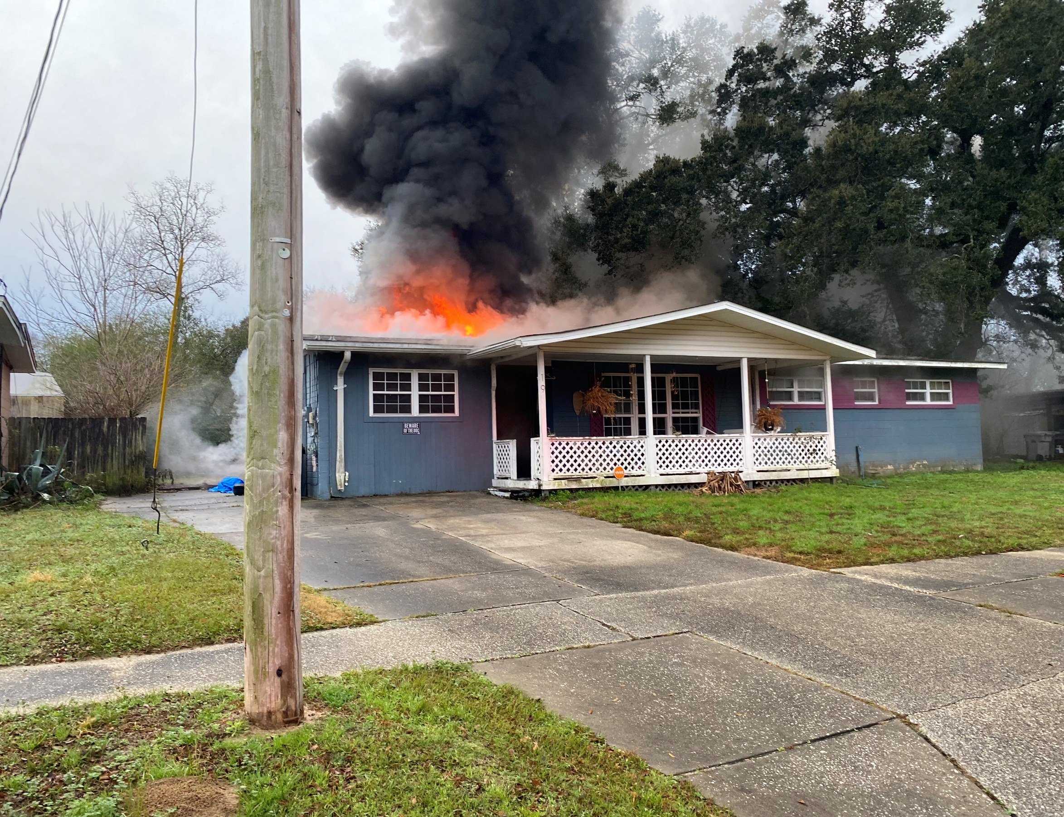

**September 2025**

|  |  |  |  |  |
| --- | --- | --- | --- | --- |
| **Date** | **Class Name** | **Training Category** | **Training Topic** | **Objective** |
| 8/31-9/6 | Vent-Enter-Search | Company | Search | Vent Enter Search |
| 9/7-9/13 | Helicopter Operations | Company | Operational Safety Classes | Helicopter Operations |
| 9/14-9/20 | Saws: Gas Powered | Company | Tools and Equipment | Gas Powered Saws |
| 9/21-9/27 | Fire Prevention Education | Company | Administrative Functions | Fire Prevention Education |

EMS: Target Solutions Spinal Chord Injuries (72809)

USAR: JPR Skill- Cutting-Saws, Cutting Torches, Battery Powered

Officer: SOG 3000.135 Accountability

Water Rescue: JPR Skill- Swimming to Victim

Driver: SOG 4000.060 Backing Fire Apparatus

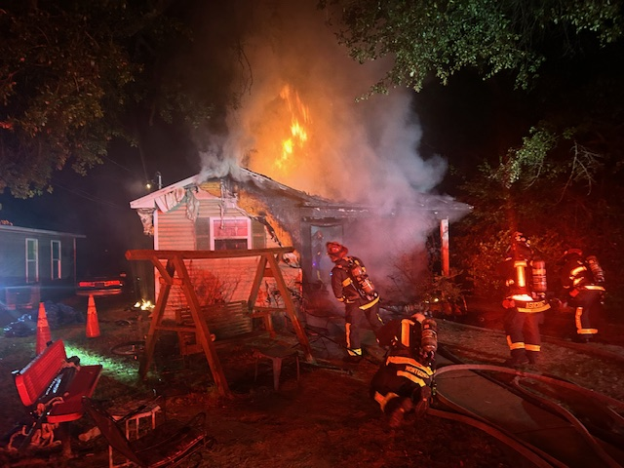

**October 2025**

|  |  |  |  |  |
| --- | --- | --- | --- | --- |
| **Date** | **Class Name** | **Training Category** | **Training Topic** | **Objective** |
| 9/28-10/4 | Ground Ladders for Rescue | Company | Portable Ladders | Carries, Raises, and Placement |
| 10/5-10/11 | Commercial Roof Operations | Company | Building Systems | Building Construction |
| 10/12-10/18 | Gustin Pack Deployments | Company | Hose | Stretching Horizontal |
| 10/19-10/25 | Rope Assisted Search | Company | Search | Rope Assisted Search |
| 10/26-11/1 | Officer Selection:  Company Specific Needs | Company | *as appropriate | *as appropriate |

**\*EMS In-Service Training October 14 or 16**

Hazmat: JPR Skill- Technical Decon

Officer: SOG 3000.155 Assistance to Law Enforcement

*Fire Station Safety Inspection (A Watch)

Driver: ATV/UTV Drivers Training

**November 2025**

|  |  |  |  |  |
| --- | --- | --- | --- | --- |
| **Date** | **Class Name** | **Training Category** | **Training Topic** | **Objective** |
| 11/2-11/8 | Residential Roof Operations | Company | Fire Behavior | Vertical Ventilation |
| 11/9-11/15 | Firefighter Survival: Bumps to Pumps | Company | Health and Safety | Firefighter Safety and Survival |
| 11/16-11/22 | Commercial Vehicle Extrication | Company | Extrication | Commercial Vehicles |
| 11/23-11/29 | Class B Fires | Company | Fire Behavior | Class B Fires |
|  | *”**Keep the Wreath Green” placed at Stations** |  |  |  |

Online Training: RT-130: Annual Wildland Fire Safety Refresher Training- Module 4 (191647)

USAR: JPR Skill- Shoring/Cribbing for Trench, VMR, Collapse Applications

Hazmat: JPR Skill- Leak Control

Officer: *Quarterly Officer Training November 18 or 20

Driver: SOG 4000.045 Special Driving Situations

HOT: Roof Ventilation at 6/12

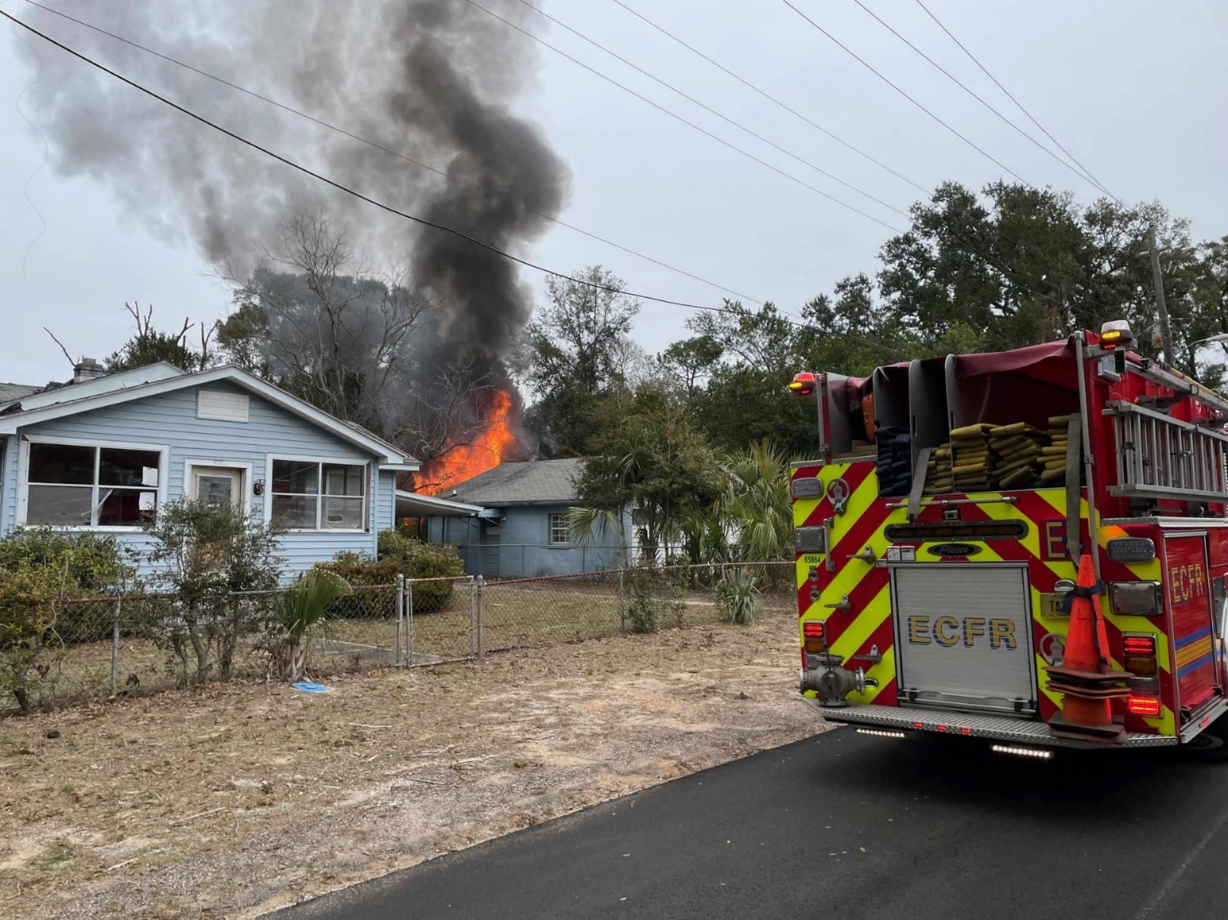

**December 2025**

|  |  |  |  |  |
| --- | --- | --- | --- | --- |
| **Date** | **Class Name** | **Training Category** | **Training Topic** | **Objective** |
| 11/30-12/6 | Rapid Intervention:  Air Options | Company | Search | Rapid Intervention Teams |
| 12/7-12/13 | Attic Fires | Company | Fire Behavior | Attic Fires |
| 12/14-12/20 | Commercial Door Construction | Company | Forcible Entry | Commercial Doors |
| 12/21-12/27 | Victim Removals | Company | Search | Victim Removal |
| 12/28-1/3 | Officer Selection:  Company Specific Need | Company | *as appropriate | *as appropriate |

Officer: 3000.165 Structure Fire Size-up

Driver: SOG 4000.040 Passing Traffic