Beach Haven NE P1
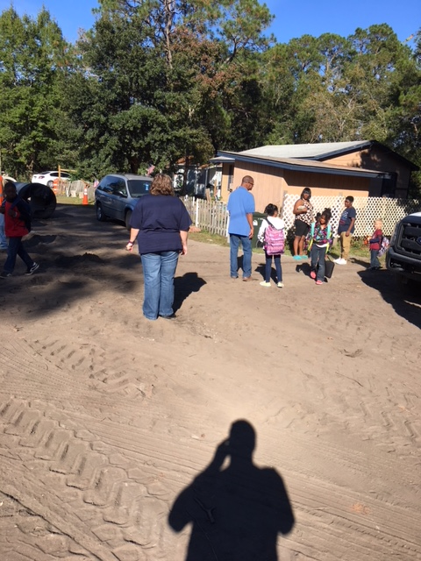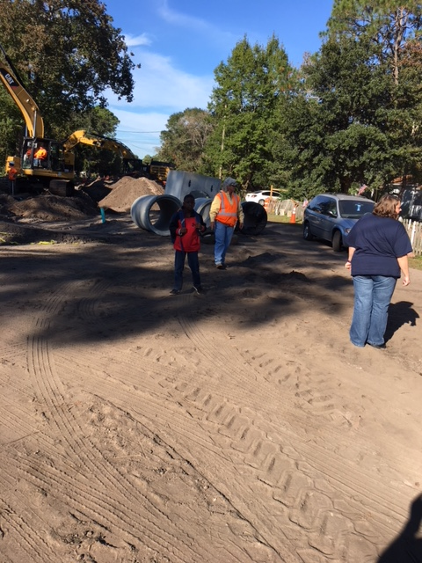
Bus stop at Mills and Cario Avenue GCUC overseeing safety of children at bus stop
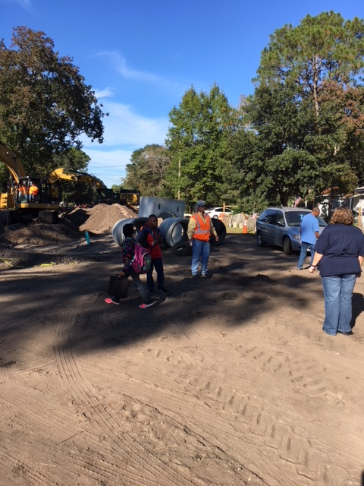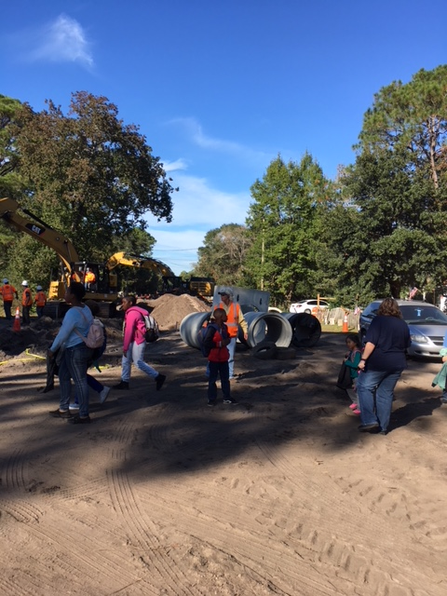
Safety of the children is top priority for contractor

